Lunartics Notes
The June Sky this month
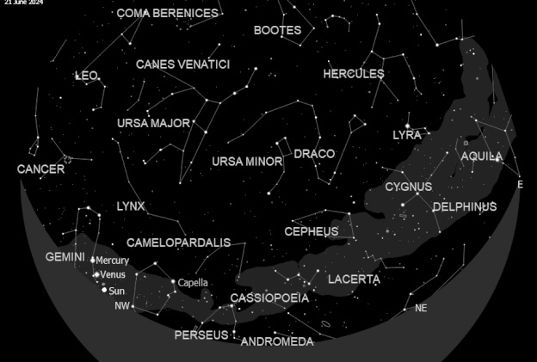
The Sky Looking North
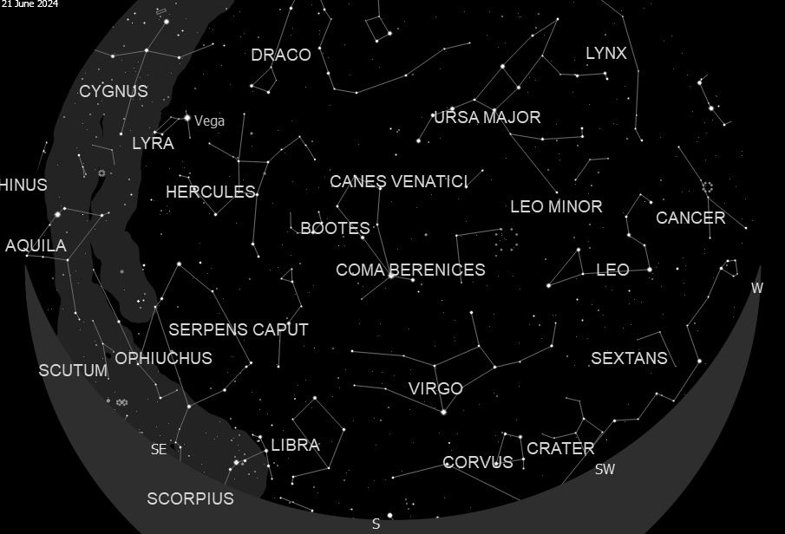
The Sky Looking South
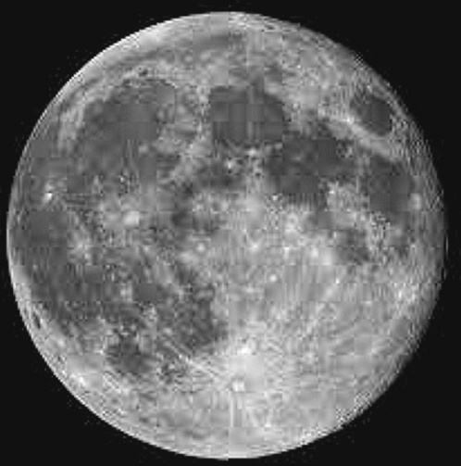
The Moon rises in the east at 9.44 BST (21.44 BST) but is quite low down and unless your horizon is clear it remains difficult to see. The Moon is full so will be quite bright even though its presentation is low, so many of the features can be washed out. If you are able to follow the Moon and observe the phases, then the Marie and the various craters become more prominent. If you have binoculars or a telescope then take a look along the ‘Terminator’, the line between the light and dark on the Moon, you should be able to see some of the mountain tops just in the sunlight in the shadow. The movement of the Earth’s atmosphere make them glisten like small jewels in the night!
The planets are not really visible this month unless you view them in the early hours

Mercury
Fairly close to the Sun. Visible only after sunset.

Venus
Fairly close to the Sun. Visible only after sunset.

Mars
View before sunrise.

Jupiter

View just before sunrise.

Saturn
View before sunrise.

Uranus
View before sunrise

Neptune
View before sunrise.

If using binoculars or telescope to view these planets at the times suggested then be aware of the sunrise times in order to avoid accidently viewing the sun and causing eye damage
Star Charts courtesy of Kstars - Lunar photo Frank Hill

