Sentimental journey by Ray Pearce
I arranged a 24-hour holiday back to where I grew up, namely Waterloo and Crosby on the West coast between Liverpool and Southport. I was ably assisted by my old school friend Keith; he lives in Formby and we both attended Waterloo Grammar school from 1946-51. He would put me up for the night.
I caught the train at 09:34 from Birmingham New St changing at South Liverpool Parkway at 11:06 for the Mersey Rail train to Freshfield arriving there at just after 12:09 noon. It was a very hot day. We went back to Keith’s house to freshen up then he drove us to the Royal Hotel on the sea front at Waterloo to meet my sister Daphne and her daughter Jacqueline and grandson Matthew.
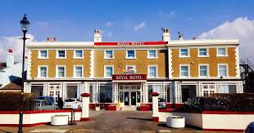
On the way we passed St Mary’s RC college for boys who most famous old boy is Cardinal Vincent Nichols, the most senior Roman Catholic cleric in England and also a Liverpool FC supporter. Less than a mile further on we drove passed Merchant Taylor’s school, Crosby who have as a former pupil Robert Runcie who was Archbishop of Canterbury from 1980-1991.
The Royal Hotel
We duly arrived at the Royal Hotel to meet up with Daphne and family, had a light lunch and a long chat before proceeding to Waterloo Grammar School. Since 1973 it has become the South Sefton Adult Education Centre, and we went to see if they would let us in. We explained at the reception desk that we were pupils from 1946-51 when it was a Grammar School. The ladies were very kind and helpful and let us have a good look round. We met some of the present adult pupils who were very keen to hear about the old times and how the school had changed. 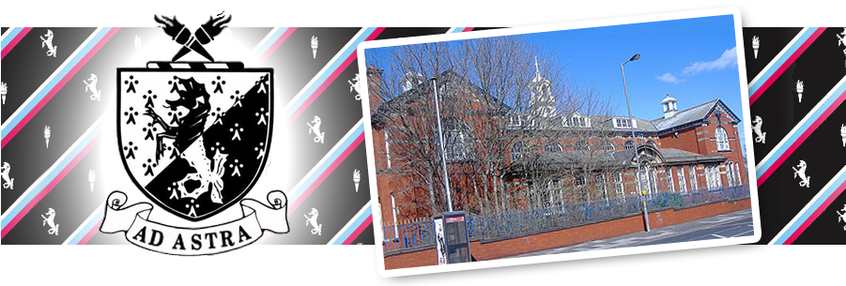 We told them some of the older masters in our time there were wounded or lost limbs in World War 1, the younger masters had just been demobbed from WW2.
We then did a tour of Waterloo and Crosby driving passed my old homes, mainly near Victoria Park where Dad was a Nursery Manager. The company proved plants and flowers for the borough. One of the houses was Oaklands Avenue where in 1953 about 12 families all went into the one house that had a TV to see the Coronation of Her Majesty, Queen Elizabeth II. We all took item of food and drink to sustain us that day. One month later I was in the Army (another story).
Passing through Little Crosby, a tiny village on the way back to Keith’s I recall potato picking after the war, back breaking work. When I had filled a bag, I was not strong enough to lift it on the cart so had to call the farmer. I recall I received 2s 6d, half a crown in old money, the first time I received cash for work in my life apart from singing in Christ Church choir at weddings and funerals.
Back at Keith’s we went out to a Toby Carvery for a meal then back by 8 pm to watch a dull 0-0 draw with England and back home the following morning.
On the way to the school, we had passed Waterloo Town Hall where I had my first job in the summer of 1951, I was a junior audit clerk in the Borough Treasurer’s Dept. I stayed in finance ending up as a Bank Manager. Keith went into Marine Engineering and was so good that he was retained by the Dutch and Singapore navies as a consultant. We have kept in touch with each other all our lives. Back home next day utterly exhausted.
Ray Pearce 27.6.24
Antony Gormley Statues at the beach at Waterloo and Crosby
