Sky Diary September 2024
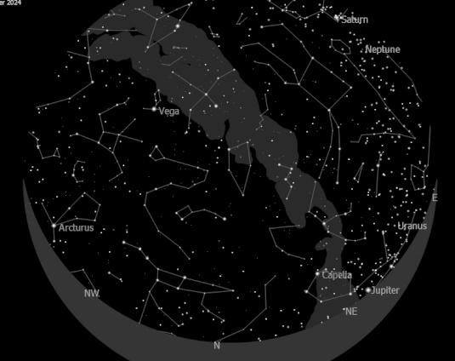

September 11.00 pm South

September 11.00 pm North
Maps courtesy of KSars
Sky Diary September 2024
For the best opportunity to stargaze and observe the sky, make sure to look on 2 September, when there is a new Moon. While you won't be able to observe the features of the Moon, you'll have slightly less light pollution in the sky.
If you look North, you'll see the constellation Cassiopeia, which is a distinctive ‘W’ shape. South of Cassiopeia, you'll be able to see the Perseus Double Cluster without a telescope, although it will just look like a hazy patch. This consists of the open star clusters NGC 869 and NGC 884, which both lie in the constellation of Perseus. If you follow the right-hand point of the ‘W’, it will guide you to Messier 31, a spiral galaxy known as the Andromeda Galaxy. This is the nearest large galaxy to our galaxy the Milky Way, and one day in the future will actually collide with us!
If you’re able to get to an extremely dark area during the new Moon, you might even be able to see a milky band of light in the sky, which is our very own Milky Way. There's even a chance of viewing a dark nebula in the Milky Way band known as the Funnel Nebula, which is a dark cloud of cosmic dust which blocks any light.
A partial lunar eclipse
If the sky is clear on 18 September, a partial lunar eclipse will occur during the night, which is when the Moon passes through a section of the Earth’s shadow.
The partial lunar eclipse will begin at 3.14am, when the Moon begins to enter Earth’s umbra (the darkest part of Earth's shadow) and will end at 4.16am when the Moon is outside the umbra. During its maximum at 3.45am, 3.5% of the Moon’s disk will be in shadow.
This eclipse should be visible across Europe, the Americas, Western Asia and Antarctica, so check the timings for your location and set your alarms. If you’re from the UK, don't miss this phenomenon as the next lunar eclipse visible in the UK won't be until 14 March 2025.
22 September is going to be an exciting day! Firstly, it's the autumn equinox, where both the day and night will be almost exactly 12 hours. This happens as the Sun’s journey through the zodiac constellations makes it pass across the celestial equator, giving the Southern Hemisphere more sunlight. It marks the beginning of autumn in the Northern Hemisphere and spring in the Southern Hemisphere- so if you're up north, get excited for longer nights of stargazing!
Moon Near the Pleiades
On the same night, you will be able to see a close approach between the Moon in a waning gibbous phase and M45, an open star cluster called the Pleiades, also known as the Seven Sisters. This asterism received its name from Greek mythology, where the myth says Zeus wanted to protect his 7 daughters from Orion, so he transformed them into stars.
Planets in September
Throughout the month many different planets will be visible.
As Mercury can only be observed in twilight, it is very hard to see without a telescope. However, if you look East on 6 September, it will be at its highest altitude in the morning sky, so you will have the best chance of viewing it then.
On 21 September, Neptune will be at opposition in the sky, meaning it is directly in line with the Sun and will have greater illumination than usual. However, due to its distance you will most likely still need a telescope to view it - for the best view try to look around midnight when it is at its maximum point in the sky.
Luckily, every night in the South the two largest planets, Jupiter and Saturn, will be visible to the naked eye. Again, with a telescope on a clear night you might be able to spot Saturn’s rings or Jupiter’s moons!
Data courtesy of the Royal Greenwich Observatory/Museum

Frank Hill

