Sky Diary October 2024
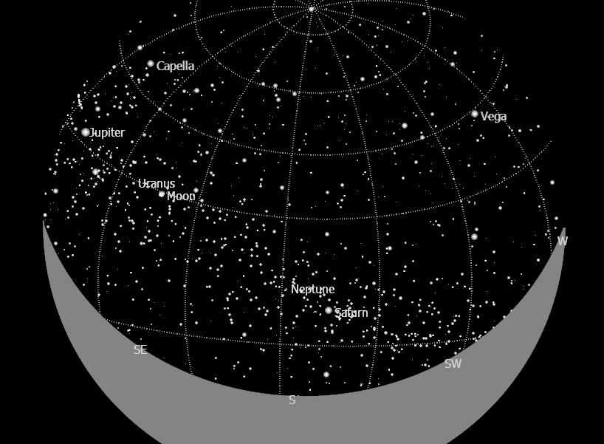

16th/17th 11.00 pm South
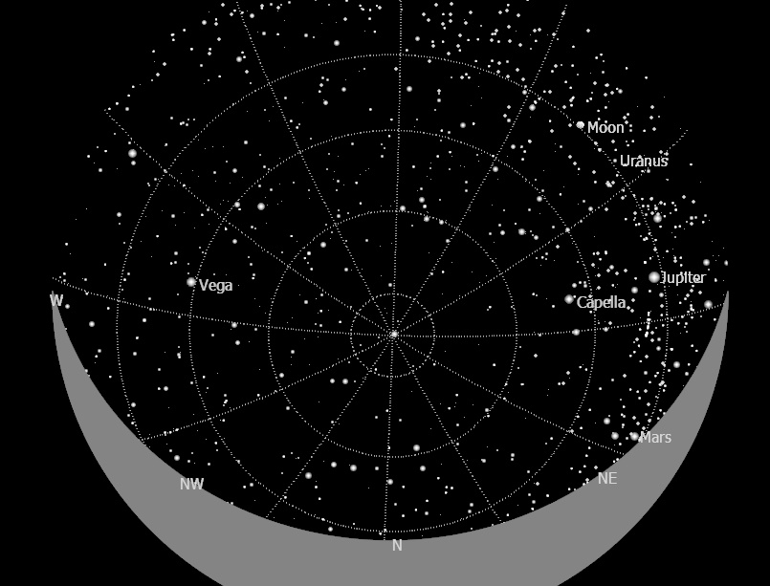

16th/17th 11.00 pm North
Maps courtesy of KSars
Sky Diary October 2024
If you look North, you'll see the constellation Cassiopeia, which is a distinctive ‘W’ shape. South of Cassiopeia, you'll be able to see the Perseus Double Cluster without a telescope, although it will just look like a hazy patch. This consists of the open star clusters NGC 869 and NGC 884, which both lie in the constellation of Perseus. If you follow the right-hand point of the ‘W’, it will guide you to Messier 31, a spiral galaxy known as the Andromeda Galaxy. This is the nearest large galaxy to our galaxy the Milky Way, and one day in the future will actually collide with us!
If you’re able to get to an extremely dark area during the new Moon, you might even be able to see a milky band of light in the sky, which is our very own Milky Way. There's even a chance of viewing a dark nebula in the Milky Way band known as the Funnel Nebula, which is a dark cloud of cosmic dust which blocks any light.
Its Autumn!
22 September was the autumnal equinox, where both the day and night will be almost exactly 12 hours. This happens as the Sun’s journey through the zodiac constellations makes it pass across the celestial equator, giving the Southern Hemisphere more sunlight. It marks the beginning of autumn in the Northern Hemisphere and spring in the Southern Hemisphere- so if you're up north, get excited for longer nights of stargazing!
The Moon
The Moon is full on the 17th October, also known as the ‘Hunters Moon’. Traditionally, people in the Northern Hemisphere spent October getting ready for the coming winter by hunting, slaughtering, and preserving meats, giving this Full Moon its Anglo-Saxon name Hunter’s Moon. Observe the moons changing phases during the month. As a guide: Shadow on the left is a waxing moon, shadow on the right is waning moon.
Planets in September
Throughout the month many different planets will be visible.
Mercury is close to the sun and is not advisable to search for it either naked eye or with an unprotected telescope or binoculars as severe eye damage can result if catching the sun while searching for the planet.
On 21 September, Neptune will be at opposition in the sky, meaning it is directly in line with the Sun and will have greater illumination than usual. However, due to its distance you will most likely still need a telescope to view it - for the best view try to look around midnight when it is at its maximum point in the sky.
Luckily, every night in the South the two largest planets, Jupiter and Saturn, will be visible to the naked eye. Again, with a telescope on a clear night you might be able to spot Saturn’s rings or Jupiter’s moons!
Solar and Planetary Data courtesy of the Royal Greenwich Observatory/Museum
Good viewing and hopefully clear skies!
Frank Hill

