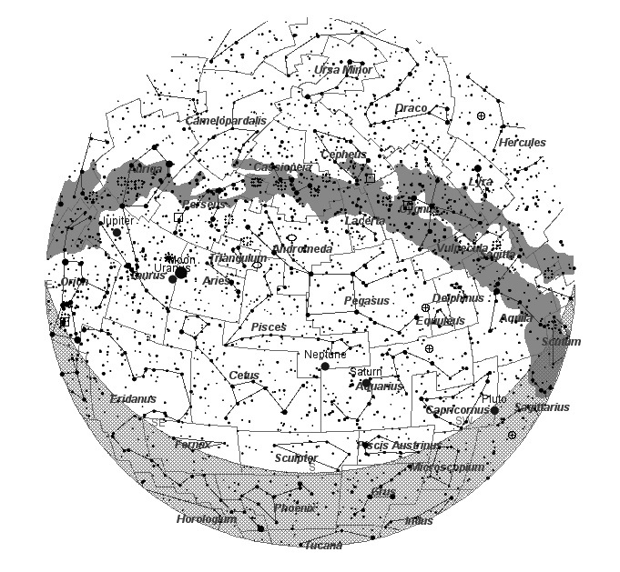
Sky Diary for November 2024

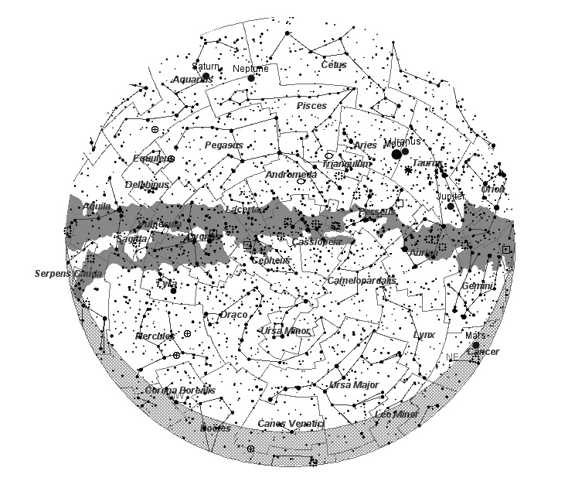

15 November Looking North at 20.00 hrs

In the Night Sky
In November we start to have some of the more well-known constellations presenting themselves for observation, as well as a vista of the more readily observable planets, Jupiter, Saturn and Mars. Venus also can be seen if you have a reasonable south western sky, low towards the horizon with a thin crescent moon nearby.
Prominent Constellations
Facing south looking from the east to the west: Mighty Orion, Taurus, the cluster Pleiades, Perseus, little Triangulum, Andromeda (host to the Andromeda Galaxy) and Pegasus.
Facing north looking from west to east: Little Delphinius (the Dolphin), just below you have Sagitta (the Arrow), Cygnus (the Swan), King Cepheus, Queen Cassiopeia, Ursa Minor (the Little Bear) with Polaris the north star, Ursa Major (the Great Bear), Auriga (the Charioteer) and Gemini (the Twins.
The Planets
In the south eastern sky, we have the giant planet Jupiter, possibly the brightest object in the sky (except the Moon of course). Viewing it through binoculars should show you the Jovian moons Io, Ganymede, Europa and Calisto. Follow their path around the planet and observe their disappearance and reappearance. Larger instrument with let you observe the belts of Jupiter, enormous bands of gas and storms.
To the south west we have the enigmatic planet Saturn, in binoculars held steady and supported you should be able to see the ring system around the planet. Not too well placed for observing at present as the rings are edge on to us, but in a year or two when they open up it is truly a magnificent sight.
Looking to the north east you will see a reddish starlike object, this is the planet Mars. On the 20th November the Moon and Mars are close together in the sky near to the Gemini Twins.
On the 15th November occurs the last of the so called ’Super Moons’ of 2024.
Comet
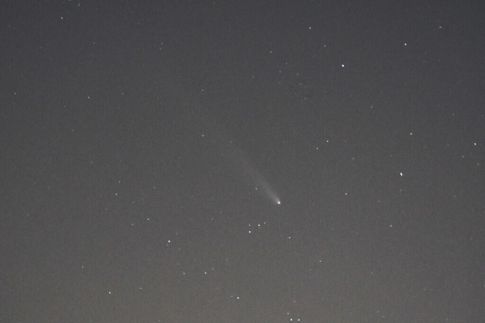
During October and early November, we have had a comet in our skies, Comet Tsuchinshan–ATLAS). The comet, providing you have a good reasonably clear western horizon should still just be observable in binoculars. Find the star Arcturus and sweep to the left and up and you may catch it. The photo was taken by Keith Middleton of the Heart of England Astronomical Society.

November is a good month, with the fading summer constellations and the rise of the Autumn and winter ones, given some clear skies make the most of them!
Maps Courtesy of KStars.
Good viewing.

Frank Hill

